Bell County Youth Fair

Ag Mechanics 2019
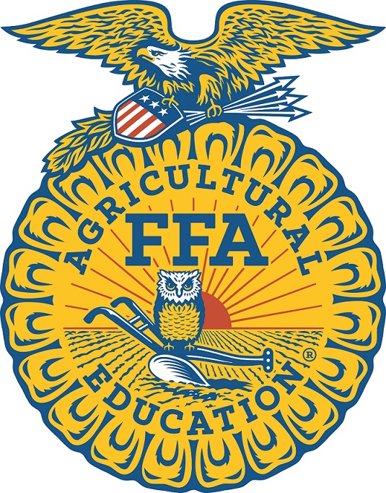

Kyle King

Salado FFA

Wood Core Rack

Hours Worked

